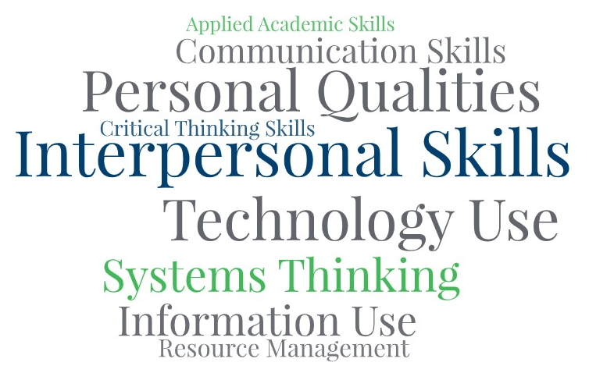


Problem-Solving and
Decision-Making
Copyright 2026
Goal Setting

All rights reserved worldwide under International and Pan-American copyright agreements. No part of this document can be reproduced, stored in a retrieval system, or transmitted in any form or by any means, electronic, mechanical, photocopying, recording, or otherwise without the prior written permission of WV Adult Basic Education.

Courseware Version: 1.0 and subsequent updates

Problem-Solving and Decision-Making

LESSON BASICS
Lesson Topic
Problem-Solving and Decision-Making

Standards (CCRS, GED Standard, Employability Skills Framework)
AK.CTS: Thinks critically
AK.CTS: Makes sound decisions
AK.CTS: Solves problems
AK.CTS. Reasons
WS.IU: Analyzes

Objectives (Audience Behavior Condition Degree)
Learners will participate in discussions and activities about problem-solving and decision-making:
- To recognize the correlation between critical thinking and problem-solving
- To identify their personal decision-making styles
- To learn to apply a logical method in solving problems and making decisions

Assessment
Instructor observation and analysis of learners' critical thinking patterns in problem-solving and decision-making activities

LESSON MATERIALS
Handouts Needed
Problem-Solving and Decision-Making Rubric
Problem-Solving Styles Questionnaire
Group Activity Scenarios
Concrete Practice Survival Activities
Online Resources
Fosbury Flop video clip: https://www.youtube.com/watch?v=5VX7sojco3s
Other Materials or Equipment
Computer, document camera, Smart Board or ViewSonic
Handouts
Pencils
Paper
Module PPT.
ACTIVITY PLAN
 | Time | Activity | Materials
Warm-up |  | Warm-Up activity: Facilitate the Critical Thinking Exercise (Giraffe in the Refrigerator) by asking students four short quiz questions. Following each question, share correct answers to explain their importance in critical thinking process.  Print and/or review the rubric with the learners. The rubric outlines what areas/objectives learners will cover.  Ask students to share any decisions they've made before coming to class today. Elicit responses to these questions:  - Does this decision impact my family in the short-term or long-term?  - How might this decision affect our lives?  Not all decisions are hard to make, and they will not impact the future drastically (ex., shirt color). However, problems will arise that require us to make decisions that will impact us now and in the future. If we approach problems using critical thinking methods, we can use our knowledge and experience to make effective decisions.
Introduction |  | Reiterate to students that when we encounter problems, we need to use critical-thinking skills (thinking outside the box) to solve problems by making effective decisions.  Watch the video Fosbury Flop: How Critical Thinking Can Change the Game. Start a discussion on how Dick Fosbury solved a problem by thinking critically. Ask students how the results of his decision affected himself and others.  Introduce and distribute the questionnaire, Problem-Solving Styles, and review the directions. Ask students to use their experience in problem-solving from the previous activity and apply to this one. Complete the first question aloud to model the ranking process, and allow learners to see how to properly score and document their responses. Allow students time to complete the activity. Discuss results and whether or not students agree or disagree with their styles.
Presentation |  | Introduce and instruct students on the four-step problem-solving/decision-making process [Christenson et al., 2008].  Step 1: Stop! Think about the problem.  When presented with a problem to solve or a decision to make, we sometimes react in an extreme manner--either by being impulsive or by procrastinating. What might happen if we react impulsively and make decisions very quickly without much thought and consideration? What might happen if we procrastinate in making a decision? How could the outcomes be different if we stopped first, then thought about it, then made the decision?  Step 2: What are some options?  One great technique in exploring problem-solving and decision-making is to write a list of possible solutions--also called options or choices. We create our list of options by brainstorming random solutions, even if they "outside of the box." After our list is full, we then eliminate those choices that won't solve the problem in an ethical, legal, or positive way.  For example, if our options include breaking the law or harming someone's property, we would mark it out as an unrealistic solution.  Step 3: Choose one.  As we look at list in progress, we may have only one or two possible choices left. In the case when there are two choices from which to pick, select the one that is most effective without causing negative effects. If there is only one viable suggestion left, it may be the best option.  Step 4: Do it.  Apply the remaining option to your situation.  Illustrate the four-step process:  Instructor presents a scenario and asks students to stop and think about the problem/decision. Instructor then asks for option suggestions to create a list on the board. You may need to make a couple of suggestions "outside of the box" to illustrate the procedure. After creating a list with several possible solutions, ask students to start eliminating suggestions that won't work (cross out these choices) and give reasons.  Announce the only option remaining, which is your solution to the problem or decision made.  Scenario:  Your kids need shirts for school, and with your limited budget, you look for a bargain on your favorite store's website. You find a great sale on children's shirts at 3 for $10! So, you rush down to the store to buy them before they're gone. You find the same shirts listed at $15 each--no sale sign in sight! What could you do?
Practice |  | 1.Divide the class into 2 or more groups. Students select a scenario (see handouts) and choose a scribe per each group. Group members stop and think about the problem/decision. Discuss. Scribe asks for option suggestions to create a list on paper. After creating a list with several possible solutions, ask students to start eliminating suggestions that won't work (cross out these choices) and give reasons. When groups have finished, share the results.  2. Instructor asks students to select one of several survival activities—Lost at Sea, Lunar Survival, or Stranded on a Mountain, to practice collaborative problem-solving and decision-making. Explain the ranking method process. On the board, list the items necessary to rank (without explanations). Ask students to brainstorm, use the four-step process to determine their answers, and write ranks next to items. When they've completed the activity, reveal the appropriate answers. Discuss reasons for rankings.
Evaluation |  | Teacher observation of learners' comprehension of concepts illustrated in activities. Complete the rubric for each learner.  Learners complete a 3-2-1 Reflection:  3-Things you learned today about problem- solving and decision-making  2-Barriers you want to improve on  1-Strategy you can implement today
Application |  | Learners share their responses to the 3-2-1 Reflection:  3-Things you learned today about problem-solving and decision making  2-Barriers you want to improve on  1-Strategy you can implement today

Other Resources or Alternative Resources

